|  |  |
| --- | --- |
|  | Student Name _______________________    **Eastern Goldfields College**  Mathematics Applications U2 2019  Assignment – Calculator Free1 |
| **Time Allowed 15 minutes** | Total Marks: 17 marks |

***Show all working when appropriate to maximise your marks.***

**Question 1 (6 marks)**

(a) Sketch the graph of a straight line that has a gradient of 2 and passes through the point (1, 2) on the set of axes below. (2)



(b) (i) Determine the equation of the line you have sketched in (a). (2)

(ii) Write down the coordinate of theintercept of the graphed equation. (1)

(iii) Show that the point (4,7) does not belong to this line. (1)

**Question 2 (11 marks)**

Two teams were competing in a problem solving competition.

The results of the first team, Team 1, are 2, 3, 3, 3, 3, 5, 7, 7, 8, 10.

(a) (i) Sketch these results as a box and whisker plot on the axis below. (4)



(ii) Determine the interquartile range and the range of the data. (2)

(b) The results of the second team, Team 2, are shown in the box and whisker plot below

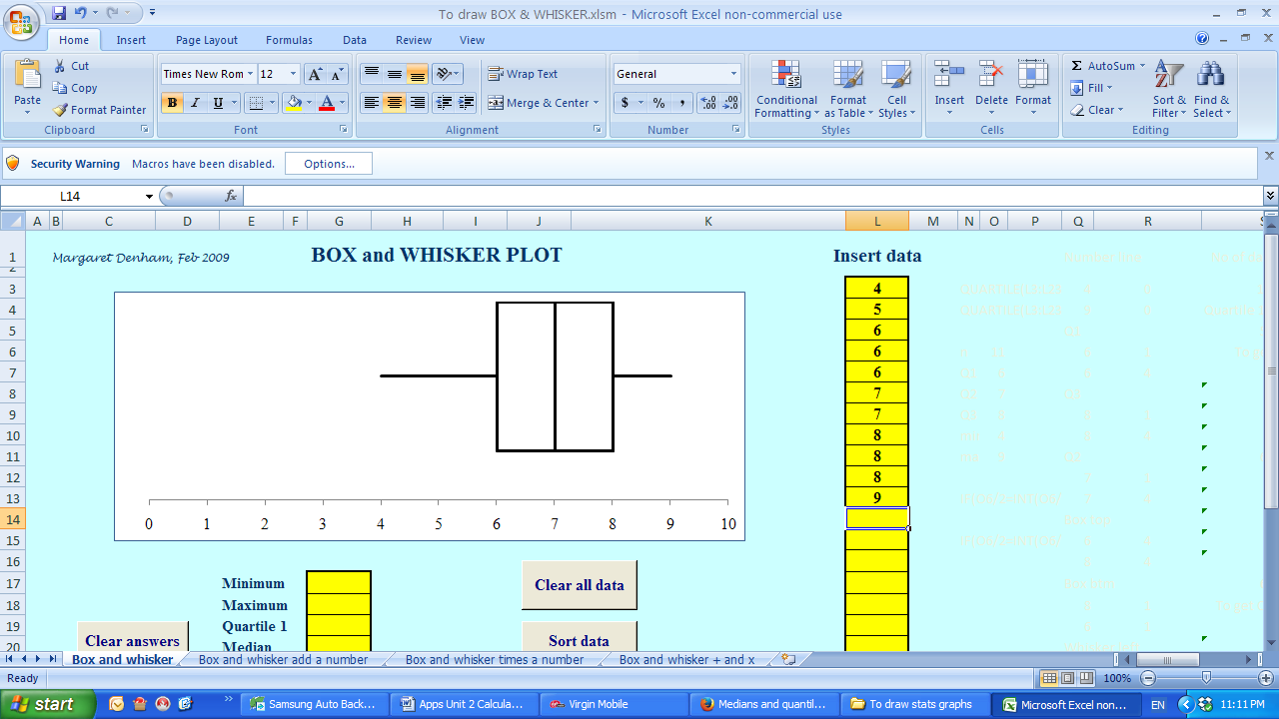



(i) Compare the spread of both sets of data. (2)

(ii) Compare the medians of both sets of data. (1)

(iii) Comment on any obvious differences in the data. (2)

|  |  |
| --- | --- |
|  | Student Name _______________________    **Eastern Goldfields College**  Mathematics Applications U2 2019  Assignment – Calculator Assumed1 |
|  | Total Marks: 16 marks |

**Time Allowed: 20 minutes**

**Calculator only, NO notes permitted for this section. Show working where appropriate.**

**Question 3 (6 marks)**

Determine the values of in the diagrams below. Give answers to 1 decimal place.

(a)

 (2)

7

(b)

 (2)

9

(c)



12

(2)

**Question 4 (5 marks)**

Sketch the following on the set of axes below:





**Question 5 (5 marks)**

Millie bought 5 small Mars bars and 3 Marzipan bars for $17.50.

Billie bought 2 small Mars bars and 4 Marzipan bars for $16.10.

1. Write an equation for each sentence.

1. Use your equations to calculate the cost of each type of bar.

END OF VALIDATION